TYPE 3
USE

The third conditional is used to talk about an imaginary or unlikely situation in the past and to describe its result.
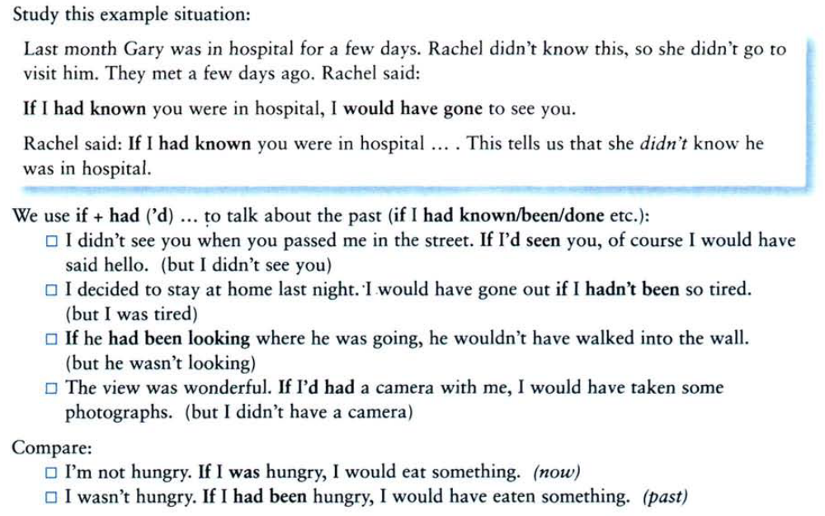

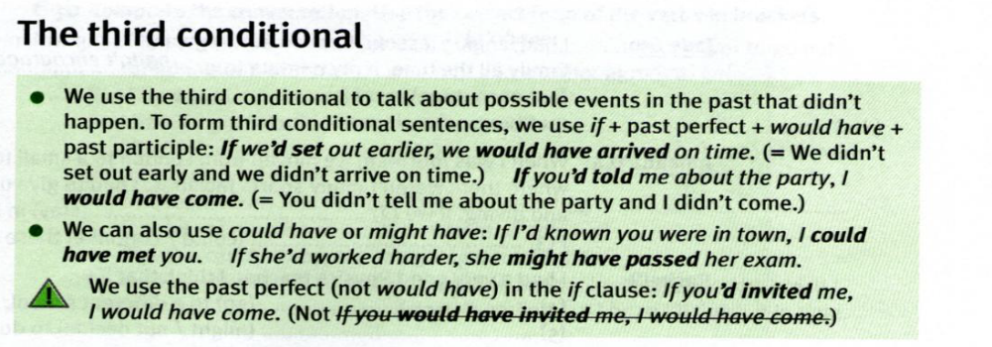

PRACTICE
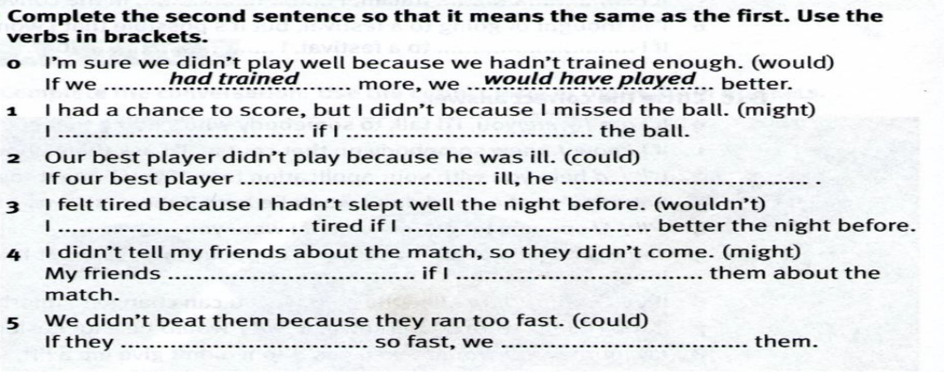
Rewrite these sentences using the third conditional.
1. Our best player didn’t play because he was ill.
_____________________________________________________________________
2. I felt tired because I hadn’t slept well the night before.
_____________________________________________________________________
3. Elliot was late for school since she didn’t hear the alarm clock.
_____________________________________________________________________
4. You didn’t phone us so we didn’t get there in time.
_____________________________________________________________________
